**Computer Science**

**Project File**

**Title: “The Mind Games”**

Name: **Abhyuday Gaur**

Class: **XI - A**

Year: **2016-2017**

Class Roll Number : **02**

Group Members:

* **Abhyuday Gaur**
* **Anant Chaturvedi**
* **Anshul Khattar**
* **Yash Shukla**

# Acknowledgement

**We are greatly indebted to our teacher,**

Mrs. Urvashi Singhal

**who throughout the tedious process of completion of the project displayed with full patience and helped me tide over the obstacles faced during this course by providing me with the necessary council and encouragement at each step and pointed out my various shortcomings in tackling this project.**

**Student’s Signature Mrs. Urvashi Singhal**

**Name: ……………………. (HOD Computer Science)**

**j0437958j0437958dd01777_**

TO MY SATISFACTION

THE MIND GAMES

Certificate of

completion

Signature

of student

signature of teacher

of class xi-a, ahlcon international school

has worked on and successfully completed the project

titled

This is to certify that

Contents

[**Acknowledgement……………………………………………………02**](#_Toc472458432)

[**Overview of C++……………………………………………………….05**](#_Toc472458433)

[**Aim and Need of Project…………………………………………05**](#_Toc472458434)

[**Hardware and Software Requirements………………..06**](#_Toc472458435)

[**Header Files Used………………………………………..………….08**](#_Toc472458436)

[**User-Defined Functions………………………………………….08**](#_Toc472458437)

[**Flow Charts………………………………………………………………09**](#_Toc472458438)

[**Flow Chart of Function “hpquiz”……………………………10**](#_Toc472458439)

[**Flow Chart of Function “sudoku”…………………………..12**](#_Toc472458440)

[**SOURCE CODE…………………………………………………………14**](#_Toc472458441)

[**OUTPUT…………………………………………………………………….39**](#_Toc472458442)

[**Bibliography………………………………………………………………43**](#_Toc472458443)

# Overview of C++

**C++ is a statistically typed, compiled, general purpose, case sensitive, free-form programming language that supports procedural, object-oriented and generic programming. C++ is regarded as a middle level language, as it comprises a combination of both high-level a****nd low-level language features.**

# Aim and Need of Project

**This Project is one of the very few of its kind. It includes two games combined into one: Sudoku and a Harry Potter Trivia Quiz. The Aim of this Project is to inculcate Calculative and Factual Thinking at the same time. While the Sudoku helps in the Calculative part, the Quiz helps in the Factual one. We Need these kinds of Projects to highlight the growing demand of brain development, which,** **endeavours like these fulfill**

# Hardware and Software Requirements

**Hardware:**

* **Intel® Core™ i5-5200U Processor**
* **8.00 GB RAM**
* **Inkjet Canon MP258**

**Software:**

* **Turbo C++**
* **Notepad++**
* **MS Word 2016**
* **Windows 10 64-bit**

# Header Files Used

(iostream.h):

* **cin and cout**
* **getline**

**(conio.h):**

* **clrscr()**
* **getch()**

**(stdlib.h): exit**

# 

# User-Defined Functions

* void hpquiz(): Used to store the Harry Potter Trivia Quiz source code and calling the function if the correct option is selected.
* **void sudoku(): Used to store the Sudoku source code and calling the function if the correct option is selected.**

# Flow Charts

General Layout of the Program

Display Choice:

1. HP Quiz
2. Sudoku;

Enter x;

Wrong Choice!

B

A

If x=’B’

If x=’A’

# Flow Chart of Function “hpquiz”

… (upto 25 questions)

True

False

False

True

Incorrect;

Correct; s++;

If a[1]= 1

Question 2;

Enter a[1];

If a[0]= 3

Question 1;

Enter a[0];

Incorrect;

Correct; s++;

Enter Name;

Guidelines for blood status;

Enter bld\_sts;

Declare a[25];

If(p>80) &&(p<=90)

If(p>70) &&(p<=80)

Remarks;

If(p>90)&&(p<=100)

If(p>50)&& (p<=60)

If p<= 50

If(p>60) &&(p<=70)

Display Result: s;

Display Percentage: p;

# Flow Chart of Function “sudoku”

Create Grid

Goto function board

Assigment of different No.s in the 3-D Array

Declare int i,j,col,row,val, sumr,sumc;

Declare char puzzle[10][10];

True

Goto board;

Output: Puzzle Solved; Exit(0);

False

Check if the solution is correct

False

True

Exit(0);

VAL=(char)val+48;

Puzzle[col-i][row-1]=VAL;

If val=0;

Input row, col, val;

# Source Code

**“The Mind Games”**

# include<iostream.h>

# include <conio.h>

#include<stdlib.h>

void hpquiz();

void sudoku();

void main()

{

clrscr();

char x;

cout<<" THE MIND GAMES"<<endl;

cout<<" ----------------"<<endl<<endl;

cout<<"A) Play Harry Potter Trivia Quiz."<<endl;

cout<<"B) Play Sudoku";

cout<<endl<<endl<<"Enter Choice (A or B): ";

cin>>x;

char qw;

cin.get(qw);

switch(x)

{

case( 'A' ): hpquiz();

break;

case( 'B' ): sudoku();

break;

default: cout<<"Wrong choice ";

break;

}

}

void hpquiz()

{

clrscr();

int a[25], s=0, p;

char name[30], bld\_sts[15];

cout<<" THE HARRY POTTER TRIVIA"<<endl;

cout<<" --------------------------"<<endl<<endl;

cout<<"Enter Your NAME: ";

cin.getline(name,30);

cout<<endl<<"Read the following instructions to know your Blood Status:"<<endl<<endl;

cout<<" 1) If You have BOTH, Read the Books and Seen the Movies; You are a PURE-BLOOD."<<endl;

cout<<" 2) If You have ONLY, Read the Books; You are a HALF-BLOOD."<<endl;

cout<<" 3) If You have ONLY, Seen the Movies; You are a MUDBLOOD."<<endl;

cout<<" 4) If You have NOT, Done any of the above; You are a SQUIB."<<endl<<endl;

cout<<" Following these Instructions, Enter Your BLOOD STATUS: ";

cin.getline(bld\_sts,15);

cout<<endl<<endl<<" ONLY THE WITTY CAN PREVAIL..."<<endl;

cout<<"--------------------------------------------------------------------------------"<<endl;

cout<<endl<<"Q1. What is the Name of Uncle Vernon s Drilling Company?"<<endl<<endl;

cout<<" 1) Drillits"<<endl;

cout<<" 2) Grunnings"<<endl;

cout<<" 3) Grunners"<<endl;

cout<<" 4) Drillos"<<endl;

cout<<endl<<"Enter Choice: ";

cin>>a[0];

if (a[0]==2)

{

cout<<endl<<"Correct."<<endl;

s++;

}

else

{

cout<<endl<<"Incorrect."<<endl;

}

cout<<endl<<"Q2. What does Profesor McGonagall Become in her Animagus Form?"<<endl<<endl;

cout<<" 1) A Tabby Cat"<<endl;

cout<<" 2) An Eagle Owl"<<endl;

cout<<" 3) A Grey Rabbit"<<endl;

cout<<" 4) A Snowy Cat"<<endl;

cout<<endl<<"Enter Choice: ";

cin>>a[1];

if (a[1]==1)

{

cout<<endl<<"Correct."<<endl;

s++;

}

else

{

cout<<endl<<"Incorrect."<<endl;

}

cout<<endl<<"Q3. What is Albus Dumbledore s Patronus?"<<endl<<endl;

cout<<" 1) A Thestral"<<endl;

cout<<" 2) A Goat"<<endl;

cout<<" 3) An Ox"<<endl;

cout<<" 4) A Phoenix"<<endl;

cout<<endl<<"Enter Choice: ";

cin>>a[2];

if (a[2]==4)

{

cout<<endl<<"Correct."<<endl;

s++;

}

else

{

cout<<endl<<"Incorrect."<<endl;

}

cout<<endl<<"Q4. Harry Potter s Patronus is a \_\_\_\_\_\_\_\_\_\_."<<endl<<endl;

cout<<" 1) Doe"<<endl;

cout<<" 2) Russell Terrier"<<endl;

cout<<" 3) Stag"<<endl;

cout<<" 4) Otter"<<endl;

cout<<endl<<"Enter Choice: ";

cin>>a[3];

if (a[3]==3)

{

cout<<endl<<"Correct."<<endl;

s++;

}

else

{

cout<<endl<<"Incorrect."<<endl;

}

cout<<endl<<"Q5. What is the Name of Dumbledore s Sister?"<<endl<<endl;

cout<<" 1) Ariana Dumbledore"<<endl;

cout<<" 2) Lucy Dumbledore"<<endl;

cout<<" 3) Hestia Dumbledore"<<endl;

cout<<" 4) Beatrix Dumbledore"<<endl;

cout<<endl<<"Enter Choice: ";

cin>>a[4];

if (a[4]==1)

{

cout<<endl<<"Correct."<<endl;

s++;

}

else

{

cout<<endl<<"Incorrect."<<endl;

}

cout<<endl<<"Q6. What is the Name of the Wizarding Prison which held GellertGrindelwald?"<<endl<<endl;

cout<<" 1) Azkaban"<<endl;

cout<<" 2) Nurmengard"<<endl;

cout<<" 3) Gringotts"<<endl;

cout<<" 4) Durmstrang"<<endl;

cout<<endl<<"Enter Choice: ";

cin>>a[5];

if (a[5]==2)

{

cout<<endl<<"Correct."<<endl;

s++;

}

else

{

cout<<endl<<"Incorrect."<<endl;

}

cout<<endl<<"Q7. Which one of these is a Marauder?"<<endl<<endl;

cout<<" 1) Snivellus"<<endl;

cout<<" 2) Mollywobbles"<<endl;

cout<<" 3) Prongs"<<endl;

cout<<" 4) Willy"<<endl;

cout<<endl<<"Enter Choice: ";

cin>>a[6];

if (a[6]==3)

{

cout<<endl<<"Correct."<<endl;

s++;

}

else

{

cout<<endl<<"Incorrect."<<endl;

}

cout<<endl<<"Q8. What does the Sign of the Deathly Hallows comprise of?"<<endl<<endl;

cout<<" 1) A Square, A Triangle and A Circle"<<endl;

cout<<" 2) A Pyramid with An Eye"<<endl;

cout<<" 3) A Pentagon and A Triangle"<<endl;

cout<<" 4) A Triangle, A Circle and A Line"<<endl;

cout<<endl<<"Enter Choice: ";

cin>>a[7];

if (a[7]==4)

{

cout<<endl<<"Correct."<<endl;

s++;

}

else

{

cout<<endl<<"Incorrect."<<endl;

}

cout<<endl<<"Q9. What are the Names of the Deathly Hallows?"<<endl<<endl;

cout<<" 1) The Deathstick, The Pebble and The Invisible Wrapper"<<endl;

cout<<" 2) The Supreme Wand, The Resurrection Stone and The Coat of Invisibility"<<endl;

cout<<" 3) The Wand of Destiny, The River Stone and The Cloth of Invisibility"<<endl;

cout<<" 4) The Elder Wand, The Resurrection Stone and The Cloak of Invisibility"<<endl;

cout<<endl<<"Enter Choice: ";

cin>>a[8];

if (a[8]==4)

{

cout<<endl<<"Correct."<<endl;

s++;

}

else

{

cout<<endl<<"Incorrect."<<endl;

}

cout<<endl<<"Q10. Where did Albus Dumbledore Die?"<<endl<<endl;

cout<<" 1) The Astronomy Tower"<<endl;

cout<<" 2) The Forbidden Forest"<<endl;

cout<<" 3) The Lost Cave"<<endl;

cout<<" 4) Hogsmeade"<<endl;

cout<<endl<<"Enter Choice: ";

cin>>a[9];

if (a[9]==1)

{

cout<<endl<<"Correct."<<endl;

s++;

}

else

{

cout<<endl<<"Incorrect."<<endl;

}

cout<<endl<<"Q11. What is the Full Name of Albus Dumbledore?"<<endl<<endl;

cout<<" 1) AlbusLoxias Egbert Pevrell Dumbledore"<<endl;

cout<<" 2) Albus Percival Wulfric Brian Dumbledore"<<endl;

cout<<" 3) AlbusGinerva Hannah Jones Dumbledore"<<endl;

cout<<" 4) Albus Percival Kendra Wulfric Dumbledore"<<endl;

cout<<endl<<"Enter Choice: ";

cin>>a[10];

if (a[10]==2)

{

cout<<endl<<"Correct."<<endl;

s++;

}

else

{

cout<<endl<<"Incorrect."<<endl;

}

cout<<endl<<"Q12. What is the Full Name of Ronald Weasley?"<<endl<<endl;

cout<<" 1) Ronald Arthur Weasley"<<endl;

cout<<" 2) Ronald Jean Weasley"<<endl;

cout<<" 3) Ronald BiliusWeasley"<<endl;

cout<<" 4) Ronald Molly Weasley"<<endl;

cout<<endl<<"Enter Choice: ";

cin>>a[11];

if (a[11]==3)

{

cout<<endl<<"Correct."<<endl;

s++;

}

else

{

cout<<endl<<"Incorrect."<<endl;

}

cout<<endl<<"Q13. Who is the Head of Beauxbaton s Academy of Magic?"<<endl<<endl;

cout<<" 1) Igor Karkaroff"<<endl;

cout<<" 2) Barty Crouch Jr."<<endl;

cout<<" 3) Ludo Bagman"<<endl;

cout<<" 4) Madame Maxime"<<endl;

cout<<endl<<"Enter Choice: ";

cin>>a[12];

if (a[12]==4)

{

cout<<endl<<"Correct."<<endl;

s++;

}

else

{

cout<<endl<<"Incorrect."<<endl;

}

cout<<endl<<"Q14. Name Ginny Weasley s Quidditch Team, after leaving Hogwarts?"<<endl<<endl;

cout<<" 1) Chudley Canons"<<endl;

cout<<" 2) Puddlemere United"<<endl;

cout<<" 3) Holyhead Harpies"<<endl;

cout<<" 4) Wimbourne Wasps"<<endl;

cout<<endl<<"Enter Choice: ";

cin>>a[13];

if (a[13]==3)

{

cout<<endl<<"Correct."<<endl;

s++;

}

else

{

cout<<endl<<"Incorrect."<<endl;

}

cout<<endl<<"Q15. Name the Secret Society founded by Dumbledore, against the Dark Arts?"<<endl<<endl;

cout<<" 1) Defence Association"<<endl;

cout<<" 2) Order of the Phoenix"<<endl;

cout<<" 3) Dumbledore s Army"<<endl;

cout<<" 4) Order of Merlin"<<endl;

cout<<endl<<"Enter Choice: ";

cin>>a[14];

if (a[14]==2)

{

cout<<endl<<"Correct."<<endl;

s++;

}

else

{

cout<<endl<<"Incorrect."<<endl;

}

cout<<endl<<"Q16. Which Potion, Induces a Powerful Obsession for something ?"<<endl<<endl;

cout<<" 1) Amortentia"<<endl;

cout<<" 2) Veritaserum"<<endl;

cout<<" 3) Draught of Living Death"<<endl;

cout<<" 4) Felix Felicis"<<endl;

cout<<endl<<"Enter Choice: ";

cin>>a[15];

if (a[15]==1)

{

cout<<endl<<"Correct."<<endl;

s++;

}

else

{

cout<<endl<<"Incorrect."<<endl;

}

cout<<endl<<"Q17. Nicolas Flamel Died at the Age of?"<<endl<<endl;

cout<<" 1) 673"<<endl;

cout<<" 2) 665"<<endl;

cout<<" 3) 662"<<endl;

cout<<" 4) 671"<<endl;

cout<<endl<<"Enter Choice: ";

cin>>a[16];

if (a[16]==2)

{

cout<<endl<<"Correct."<<endl;

s++;

}

else

{

cout<<endl<<"Incorrect."<<endl;

}

cout<<endl<<"Q18. Who is the Author of Hogwarts: A History ?"<<endl<<endl;

cout<<" 1) BathildaBagshot"<<endl;

cout<<" 2) Gilderoy Lockhart"<<endl;

cout<<" 3) Libatius Borage"<<endl;

cout<<" 4) Rita Skeeter"<<endl;

cout<<endl<<"Enter Choice: ";

cin>>a[17];

if (a[17]==1)

{

cout<<endl<<"Correct."<<endl;

s++;

}

else

{

cout<<endl<<"Incorrect."<<endl;

}

cout<<endl<<"Q19. What is the Full Form of SPEW?"<<endl<<endl;

cout<<" 1) Society for Purification of Elder Wizardary"<<endl;

cout<<" 2) Society for Procastination of Elfish Warfare"<<endl;

cout<<" 3) Society for Protection of Elfish Welfare"<<endl;

cout<<" 4) Society for Protection of the Elder Wand"<<endl;

cout<<endl<<"Enter Choice: ";

cin>>a[18];

if (a[18]==3)

{

cout<<endl<<"Correct."<<endl;

s++;

}

else

{

cout<<endl<<"Incorrect."<<endl;

}

cout<<endl<<"Q20. Which Dragon did Viktor Krum face in the First Task of the Triwizard Tournament?"<<endl<<endl;

cout<<" 1) Common Welsh Green"<<endl;

cout<<" 2) Hungarian Horntail"<<endl;

cout<<" 3) Swedish Short Snout"<<endl;

cout<<" 4) Chinese Fireball"<<endl;

cout<<endl<<"Enter Choice: ";

cin>>a[19];

if (a[19]==4)

{

cout<<endl<<"Correct."<<endl;

s++;

}

else

{

cout<<endl<<"Incorrect."<<endl;

}

cout<<endl<<"Q21. Which Magical Technique resists the External Penetration of the Mind through Magic?"<<endl<<endl;

cout<<" 1) Arithmancy"<<endl;

cout<<" 2) Legilimency"<<endl;

cout<<" 3) Occlumency"<<endl;

cout<<" 4) Attornomency"<<endl;

cout<<endl<<"Enter Choice: ";

cin>>a[20];

if (a[20]==3)

{

cout<<endl<<"Correct."<<endl;

s++;

}

else

{

cout<<endl<<"Incorrect."<<endl;

}

cout<<endl<<"Q22. In Which Story in The Tales of Beedle The Bard , are the Deathly Hallows Introduced?"<<endl<<endl;

cout<<" 1) The Tale of The Three Brothers"<<endl;

cout<<" 2) The Fountain of Fair Fortune"<<endl;

cout<<" 3) The Warlock s Hairy Heart"<<endl;

cout<<" 4) The Wizard and The Hopping Pot"<<endl;

cout<<endl<<"Enter Choice: ";

cin>>a[21];

if (a[21]==1)

{

cout<<endl<<"Correct."<<endl;

s++;

}

else

{

cout<<endl<<"Incorrect."<<endl;

}

cout<<endl<<"Q23. What is the Core of the Elder Wand?"<<endl<<endl;

cout<<" 1) Two Feathers from the Tail of the Phoenix Supreme"<<endl;

cout<<" 2) Single Hair from the Tail of a Thestral"<<endl;

cout<<" 3) Twelve Hairs from the Tail of a Fully Mature Unicorn"<<endl;

cout<<" 4) Single Dragon Heartstring from the Unruly Beast of Dragons breed)"<<endl;

cout<<endl<<"Enter Choice: ";

cin>>a[22];

if (a[22]==2)

{

cout<<endl<<"Correct."<<endl;

s++;

}

else

{

cout<<endl<<"Incorrect."<<endl;

}

cout<<endl<<"Q24. What is the Name of the Broom Harry Potter got on his 13th Birthday?"<<endl<<endl;

cout<<" 1) Shooting Star"<<endl;

cout<<" 2) Nimbus 2000"<<endl;

cout<<" 3) Nimbus 2001"<<endl;

cout<<" 4) Firebolt"<<endl;

cout<<endl<<"Enter Choice: ";

cin>>a[23];

if (a[23]==4)

{

cout<<endl<<"Correct."<<endl;

s++;

}

else

{

cout<<endl<<"Incorrect."<<endl;

}

cout<<endl<<"Q25. What is the Name of the Child of Remus Lupin and Nymphadora Tonks?"<<endl<<endl;

cout<<" 1) Teddy Lupin"<<endl;

cout<<" 2) Andromeda Tonks"<<endl;

cout<<" 3) Hugo Tonks"<<endl;

cout<<" 4) Peter Lupin"<<endl;

cout<<endl<<"Enter Choice: ";

cin>>a[24];

if (a[24]==1)

{

cout<<endl<<"Correct."<<endl;

s++;

}

else

{

cout<<endl<<"Incorrect."<<endl;

}

cout<<"-------------------------------------------------------------------------------"<<endl;

cout<<" TEST COMPLETE."<<endl;

cout<<"-------------------------------------------------------------------------------"<<endl;

cout<<endl<<" RESULTS"<<endl;

cout<<"---------"<<endl<<endl;

cout<<"Total Score: "<<s<<" out of 25."<<endl;

p=s\*4;

cout<<"Percentage of Merit: "<<p<<"%."<<endl<<endl;

cout<<"Remarks:"<<endl<<endl;

if (p<=50)

{

cout<<"TROLL. Don t Consider Yourself A Harry Potter Fan if You don t know THIS!!!";

}

else if ((p>50)&&(p<=60))

{

cout<<"DREADFUL. You Need to Get Your BASICS Clear, My Friend!!";

}

else if ((p>60)&&(p<=70))

{

cout<<"POOR. You Need To Work HARD, My Friend!";

}

else if ((p>70)&&(p<=80))

{

cout<<"ACCEPTABLE. GOOD JOB! Keep Working Hard.";

}

else if ((p>80)&&(p<=90))

{

cout<<"EXCEEDS EXPECTATIONS. Splendid Work. A LITTLE MORE and You ll go Places!!";

}

else if ((p>90)&&(p<=100))

{

cout<<"OUTSTANDING! You Have Proved That You Are A WORTHY WIZARD!!!";

}

getch();

}

void sudoku()

{

clrscr();

cout<<" SUDOKU"<<endl;

cout<<" --------"<<endl<<endl;

int i,j,row,col,val,sumr=0,sumc=0;

int puzzle[9][9];

for(i=0;i<9;i++)

{

for(j=0;j<9;j++)

{

puzzle[i][j] = 0;

}

}

{

puzzle[0][0] = 4; puzzle[0][5] = 2; puzzle[0][7] = 9; puzzle[0][8] = 5;

puzzle[1][0] = 9; puzzle[1][1] = 5; puzzle[1][4] = 1; puzzle[1][8] = 2;

puzzle[2][4] = 9; puzzle[2][5] = 4;

puzzle[3][0] = 5; puzzle[3][2] = 1; puzzle[3][3] = 4; puzzle[3][5] = 8;

puzzle[4][1] = 4; puzzle[4][2] = 9; puzzle[4][6] = 3; puzzle[4][7] = 6;

puzzle[5][3] = 1; puzzle[5][5] = 9; puzzle[5][6] = 5; puzzle[5][7] = 8;

puzzle[6][3] = 6; puzzle[6][4] = 4;

puzzle[7][1] = 6; puzzle[7][4] = 2; puzzle[7][7] = 8; puzzle[7][8] = 3;

puzzle[8][0] = 7; puzzle[8][1] = 2; puzzle[8][3] = 8; puzzle[8][8] = 9;

}

board:

{

cout<<" 1 2 3 4 5 6 7 8 9"<<endl<<endl<< "1 "<< puzzle[0][0]<< " " << puzzle[1][0]<< " " << puzzle[2][0]<< "|"<< puzzle[3][0]<< " " << puzzle[4][0]<< " " << puzzle[5][0]<< "|"<< puzzle[6][0]<< " " << puzzle[7][0]<< " " << puzzle[8][0]<<endl;

cout<< "2 "<< puzzle[0][1]<< " " << puzzle[1][1]<< " " << puzzle[2][1]<< "|"<< puzzle[3][1]<< " " << puzzle[4][1]<< " " << puzzle[5][1]<< "|"<< puzzle[6][1]<< " " << puzzle[7][1]<< " " << puzzle[8][1]<<endl;

cout<< "3 "<< puzzle[0][2]<< " " << puzzle[1][2]<< " " << puzzle[2][2]<< "|"<< puzzle[3][2]<< " " << puzzle[4][2]<< " " << puzzle[5][2]<< "|"<< puzzle[6][2]<< " " << puzzle[7][2]<< " " << puzzle[8][2]<<endl;

cout<< " -----+-----+-----"<<endl;

cout<< "4 "<< puzzle[0][3]<< " " << puzzle[1][3]<< " " << puzzle[2][3]<< "|"<< puzzle[3][3]<< " " << puzzle[4][3]<< " " << puzzle[5][3]<< "|"<< puzzle[6][3]<< " " << puzzle[7][3]<< " " << puzzle[8][3]<<endl;

cout<< "5 "<< puzzle[0][4]<< " " << puzzle[1][4]<< " " << puzzle[2][4]<< "|"<< puzzle[3][4]<< " " << puzzle[4][4]<< " " << puzzle[5][4]<< "|"<< puzzle[6][4]<< " " << puzzle[7][4]<< " " << puzzle[8][4]<<endl;

cout<< "6 "<< puzzle[0][5]<< " " << puzzle[1][5]<< " " << puzzle[2][5]<< "|"<< puzzle[3][5]<< " " << puzzle[4][5]<< " " << puzzle[5][5]<< "|"<< puzzle[6][5]<< " " << puzzle[7][5]<< " " << puzzle[8][5]<<endl;

cout<< " -----+-----+-----" <<endl;

cout<< "7 "<< puzzle[0][6]<< " " << puzzle[1][6]<< " " << puzzle[2][6]<< "|"<< puzzle[3][6]<< " " << puzzle[4][6]<< " " << puzzle[5][6]<< "|"<< puzzle[6][6]<< " " << puzzle[7][6]<< " " << puzzle[8][6]<<endl;

cout<< "8 "<< puzzle[0][7]<< " " << puzzle[1][7]<< " " << puzzle[2][7]<< "|"<< puzzle[3][7]<< " " << puzzle[4][7]<< " " << puzzle[5][7]<< "|"<< puzzle[6][7]<< " " << puzzle[7][7]<< " " << puzzle[8][7]<<endl;

cout<< "9 "<< puzzle[0][8]<< " " << puzzle[1][8]<< " " << puzzle[2][8]<< "|"<< puzzle[3][8]<< " " << puzzle[4][8]<< " " << puzzle[5][8]<< "|"<< puzzle[6][8]<< " " << puzzle[7][8]<< " " << puzzle[8][8];

};

cout<<"\nEnter Coordinates: ";

cout<<endl<<"Row: ";

cin>>row;

cout<<endl<<"Column: ";

cin>>col;

cout<<"\nEnter Value(from 1-9).Enter 0 to exit: ";

cin>>val;

if(val==0)

{

exit(0);

}

else

{

puzzle[col-1][row-1] = val;

}

for(i=0;i<9;i++)

{

for(j=0;j<9;j++)

{

sumr+=puzzle[i][j];

sumc+= puzzle[j][i];

}

}

if ((sumr==45)&&(sumc==45))

{

cout<<"Congratulations, you have solved the puzzle!";

exit(0);

}

else

{ goto board; }

getch();

}

# Output

**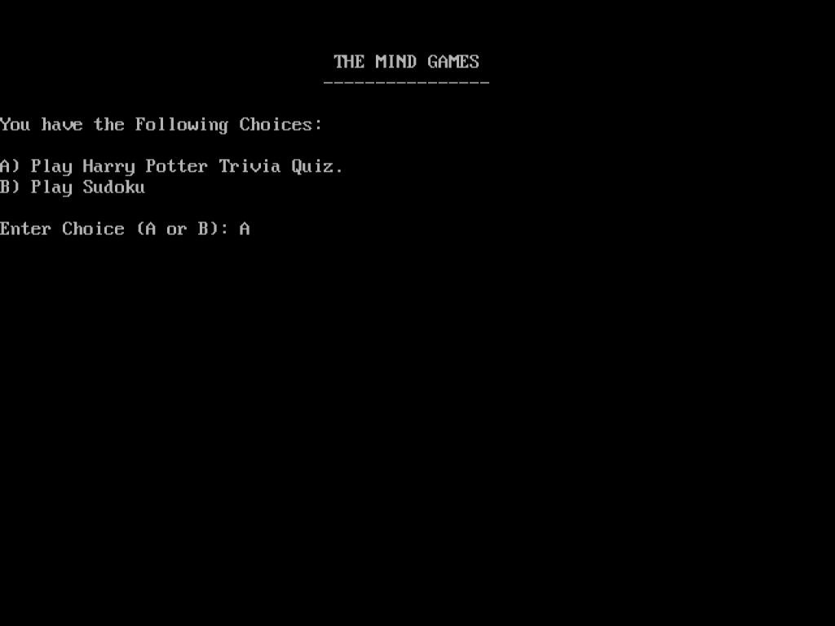**

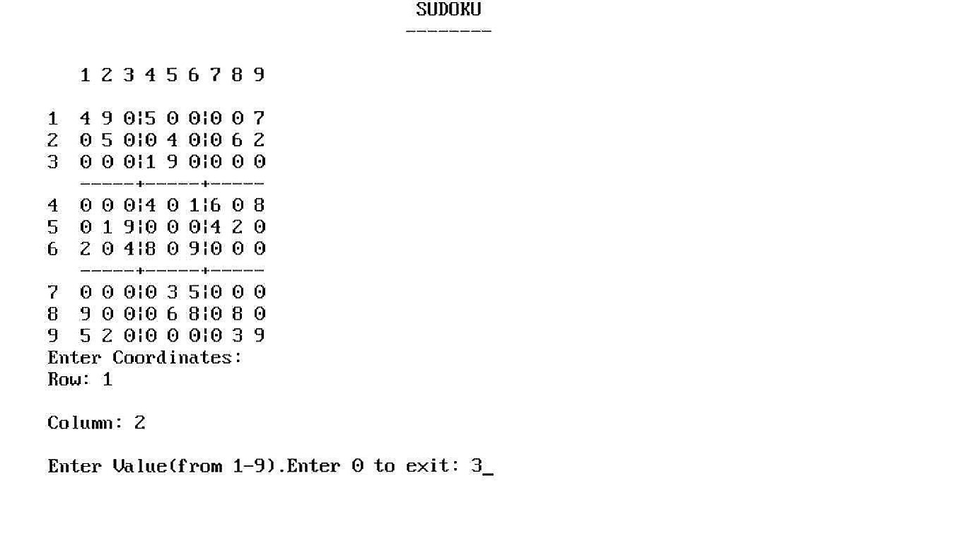

**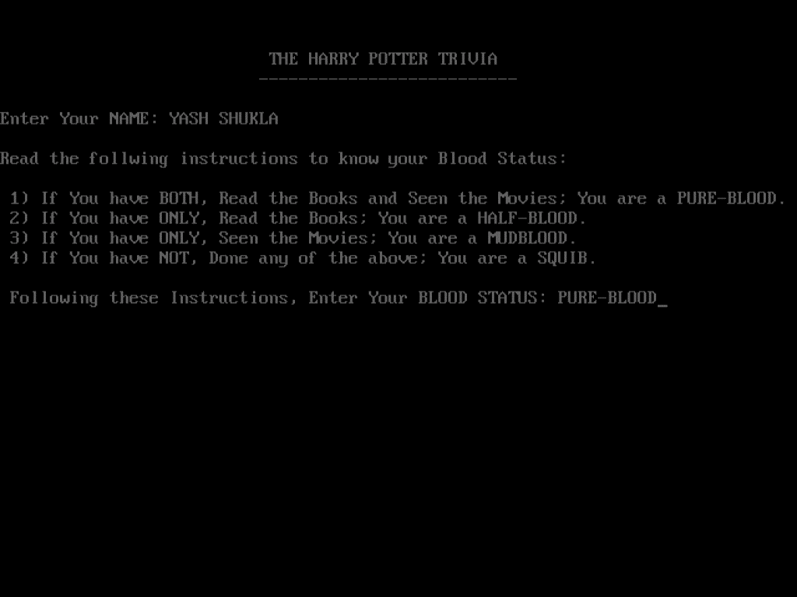**

**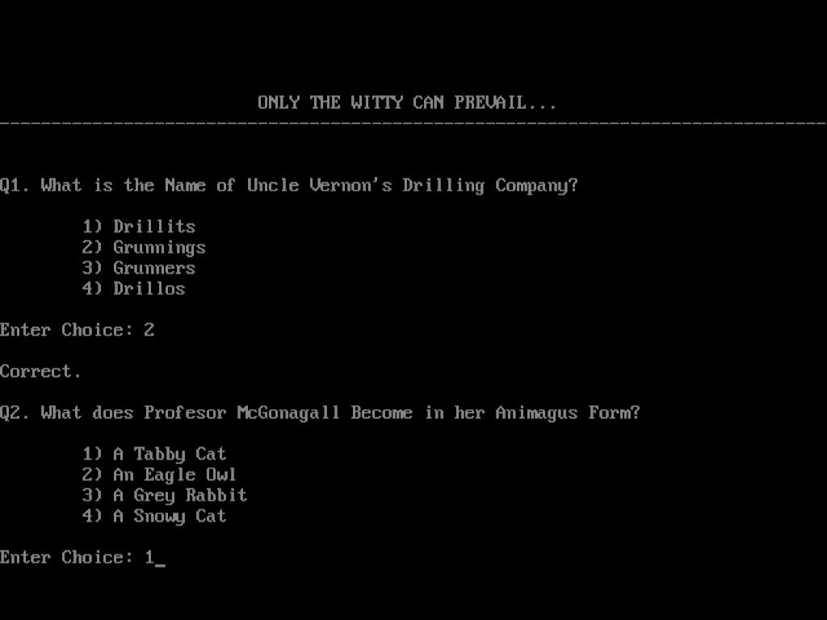**

**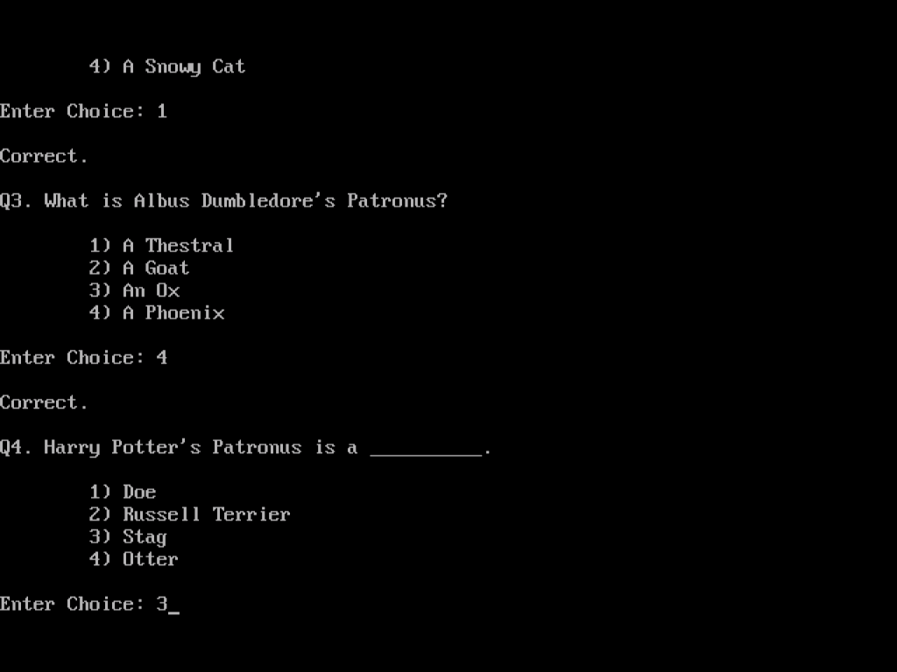**

**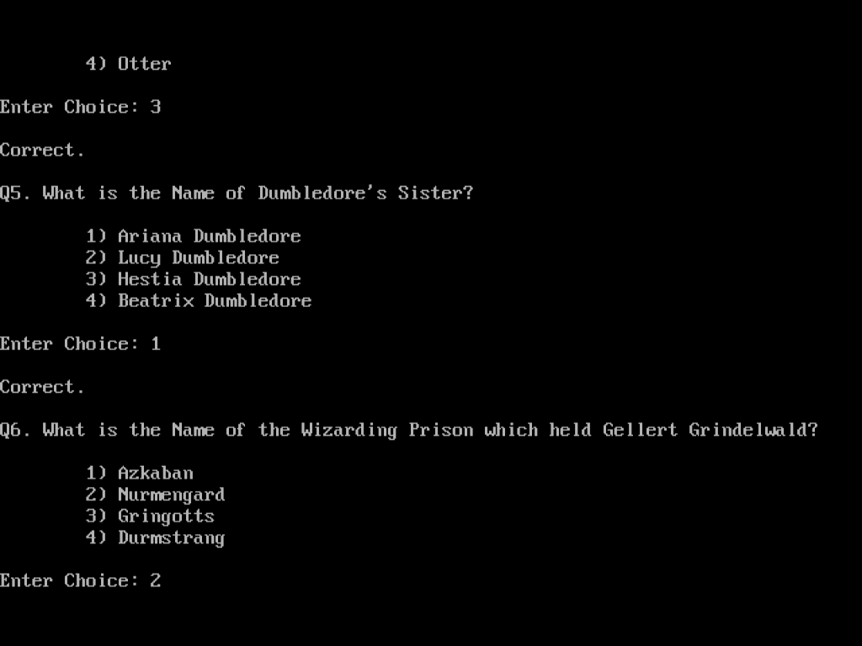**

**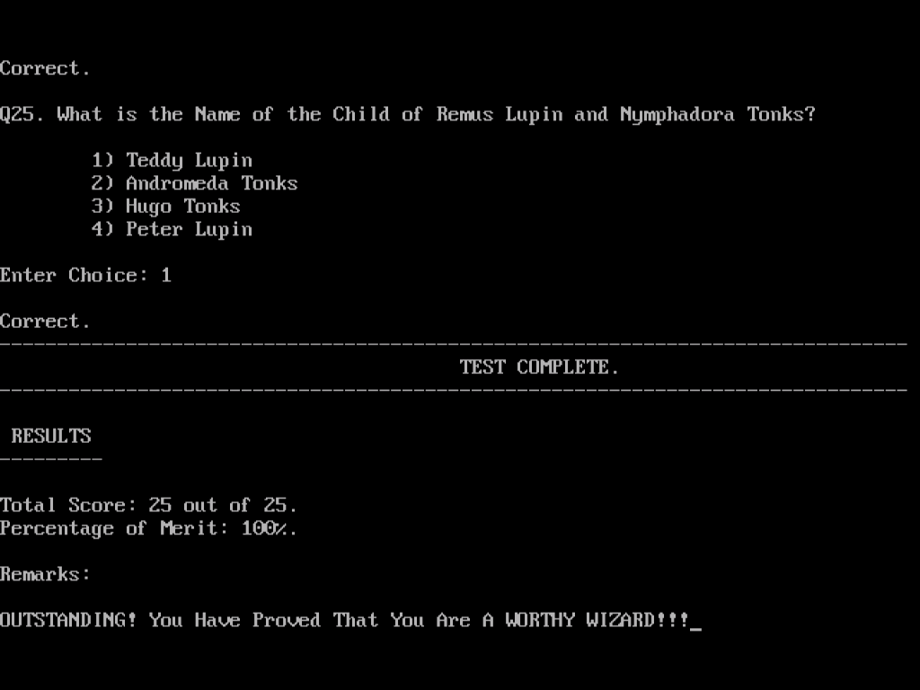**

# Bibliography

* **Computer Science with C++, Class XI by Sumita Arora**
* **Uravashi Ma’am’s Teachings**
* **www.google.com**
* **www.cplusplus.com**